STP Attacks Analysis Using Yersinia and Wireshark

# 1. Introduction

The goal of this project is to test potential vulnerabilities in the Spanning Tree Protocol (STP) within a controlled, isolated network environment using Kali Linux, Yersinia, and Wireshark.   
Attacks 0–6 were tested as part of an ethical hacking demonstration.

# 2. Environment Setup

- Kali Linux with Yersinia installed  
- Ubuntu with Wireshark  
- Virtual test environment VirtualBox  
- Interface setup: promiscuous mode, bridged networking

# 3. Attack Descriptions

## Attack 0

**Type:** Configuration BPDU flood

**Objective:** Send a large number of BPDUs to the network to disrupt the normal operation of the STP.

**Expected Outcome:** The network can recalculate the topology, and time loops and delays may occur.

**Process:**

Attack 0 was launched five times in Yersinia

Wireshark uses the stp filter

5 STP packets of the Configuration BPDU type were fixed

**Test Result:**

All BPDU packages contain the same Root Identifier, replacing the real Root Bridge.

The parameters are disclosed:

Root ID: 24576 / 882 / 76:0f:00:14:5a:25

Bridge ID: 8192 / 3833 / e7:cd:90:11:8d:43

Port ID: 0x8002

The packets were successfully captured in Wireshark, and the attack was sent correctly.

**Conclusion:**

The attack was technically successful (the BPDU was sent and accepted by Wireshark), but its effectiveness in intercepting the Root role is limited. Nevertheless, it demonstrates knowledge of the STP protocol and skills in dealing with L2 attacks in a controlled environment.

In future attacks, to increase efficiency, you should:

Get root priority = 0 in Yersinia

Use a custom MAC bridge = Root MAC

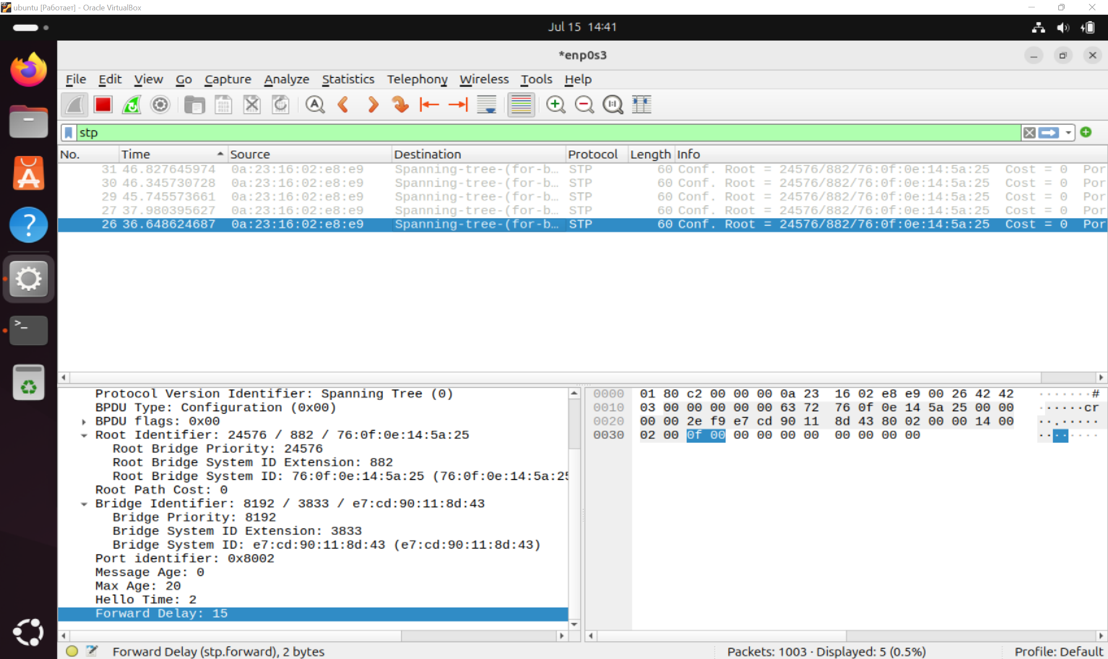

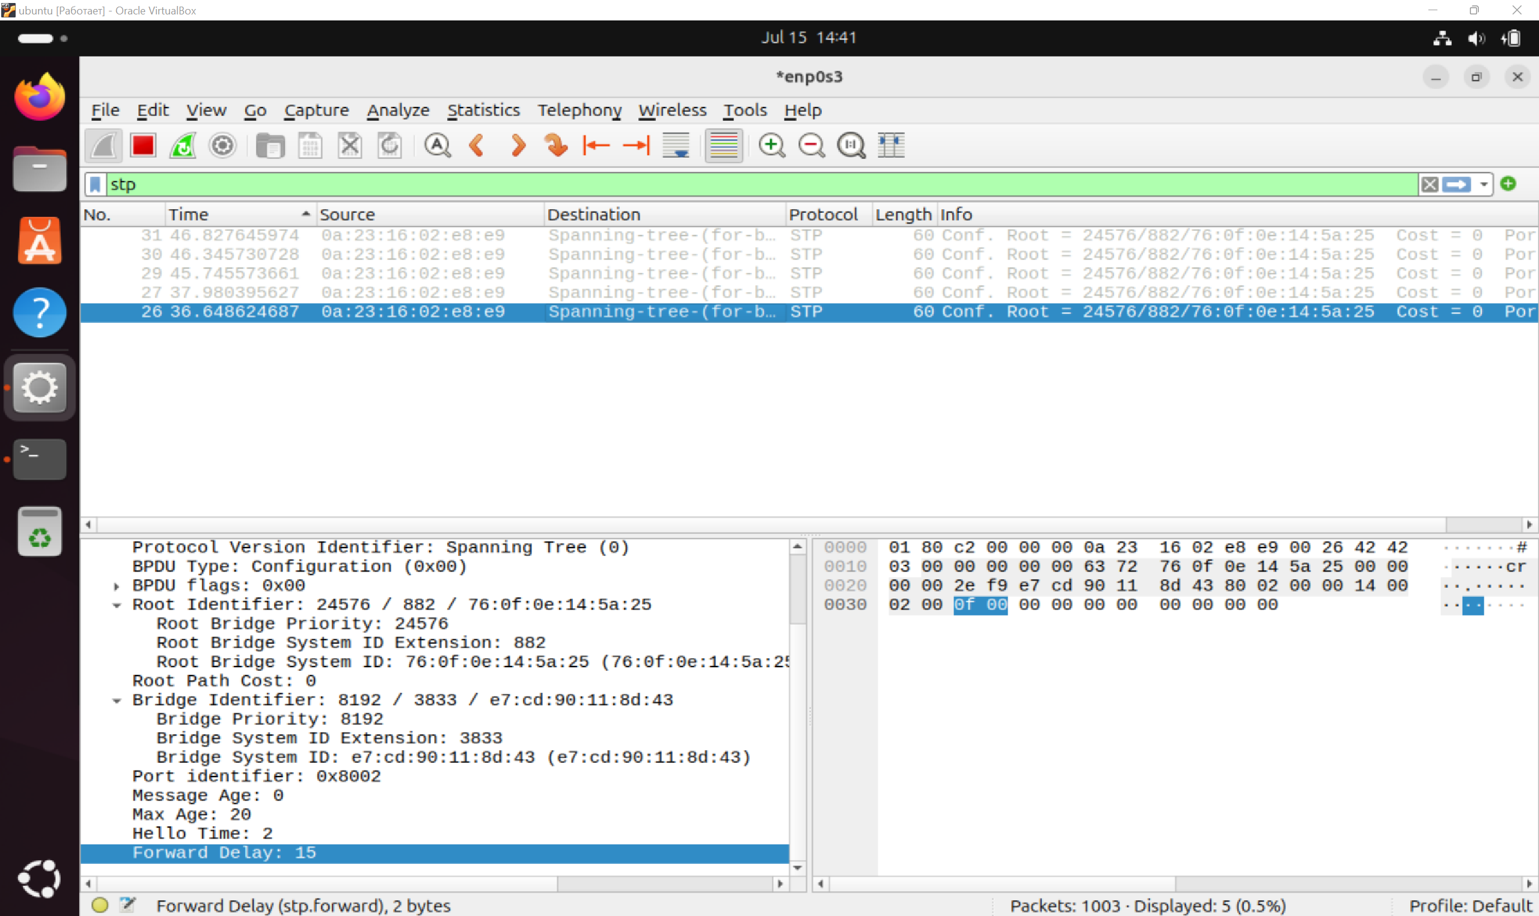

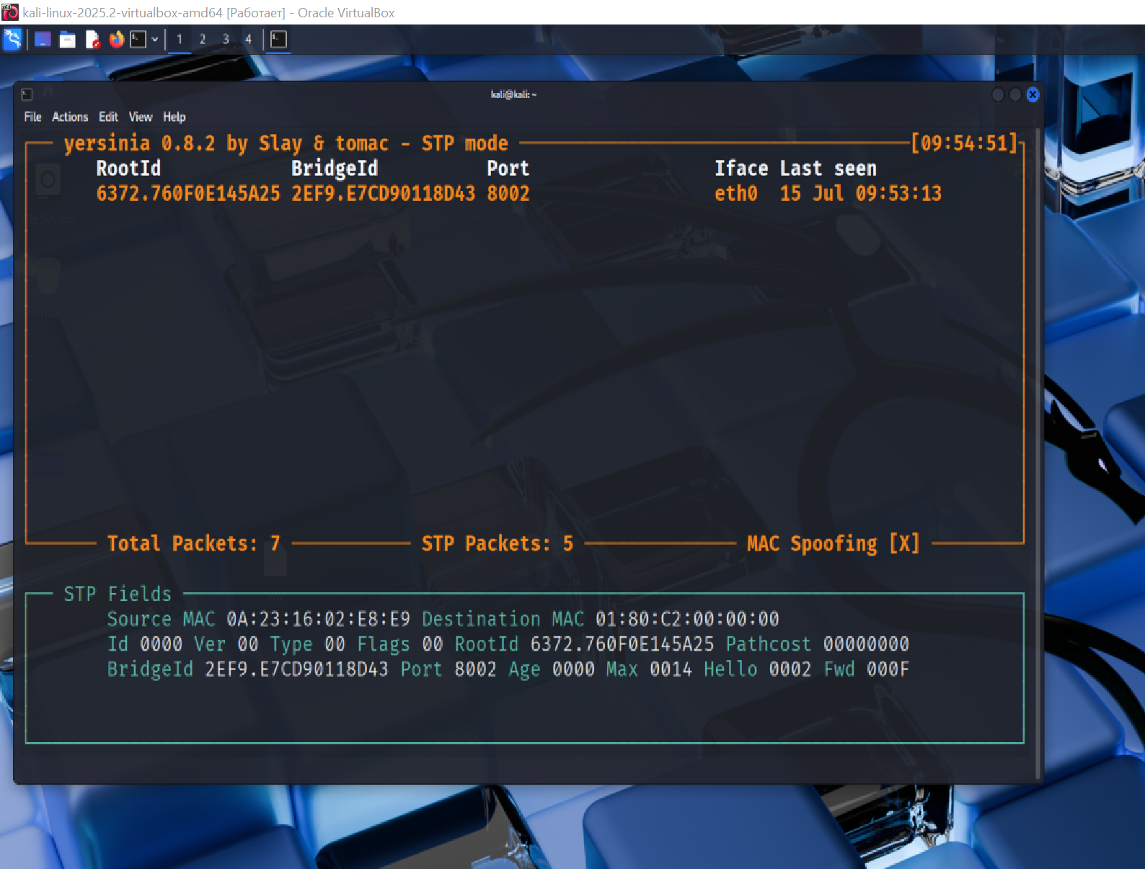

## Attack 1

**Type:** Spanning Tree Protocol – Topology Change Notification (TCN) BPDU Injection

**Objective:** Simulate a network topology change by sending a fake TCN BPDU to force Root Bridge and other switches to initiate route recalculation and/or reset MAC tables.

**Expected Outcome:**

The Root Bridge receives a notification about the topology change.

The entire STP network recalculates the tree.

Switches reset MAC tables.

**Process:**

In Yersinia, the 1 - Sending TCN BPDU attack was selected.

The attack was executed once.

Wireshark on Ubuntu captured packets with the stp filter.

The TCN BPDU packet was captured, which is **confirmed:**

BPDU Type: 0x80 (Top Change Notification),

Protocol Identifier: 0x0000,

Source MAC address: 00:23:16:02:e8:e9.

**Test Result:**

The attack was successfully detected in Wireshark.

The correct TCN BPDU was received.:

Packet size: 60 bytes,

BPDU Type: 0x80 — corresponds to TCN.

Root substitution was not performed, but a signal about the topology change was sent.

No BPDU responses were recorded from the network — there was no second switch in the test environment.

**Conclusion:** The attack was successful: the Topology Change Notification package was sent and recorded. This demonstrates knowledge of the internal logic of STP operation and the ability to initiate routing changes to L2.

To increase efficiency: use multiple TCN

sending,analyze the response of other devices to the BPDU Configuration. 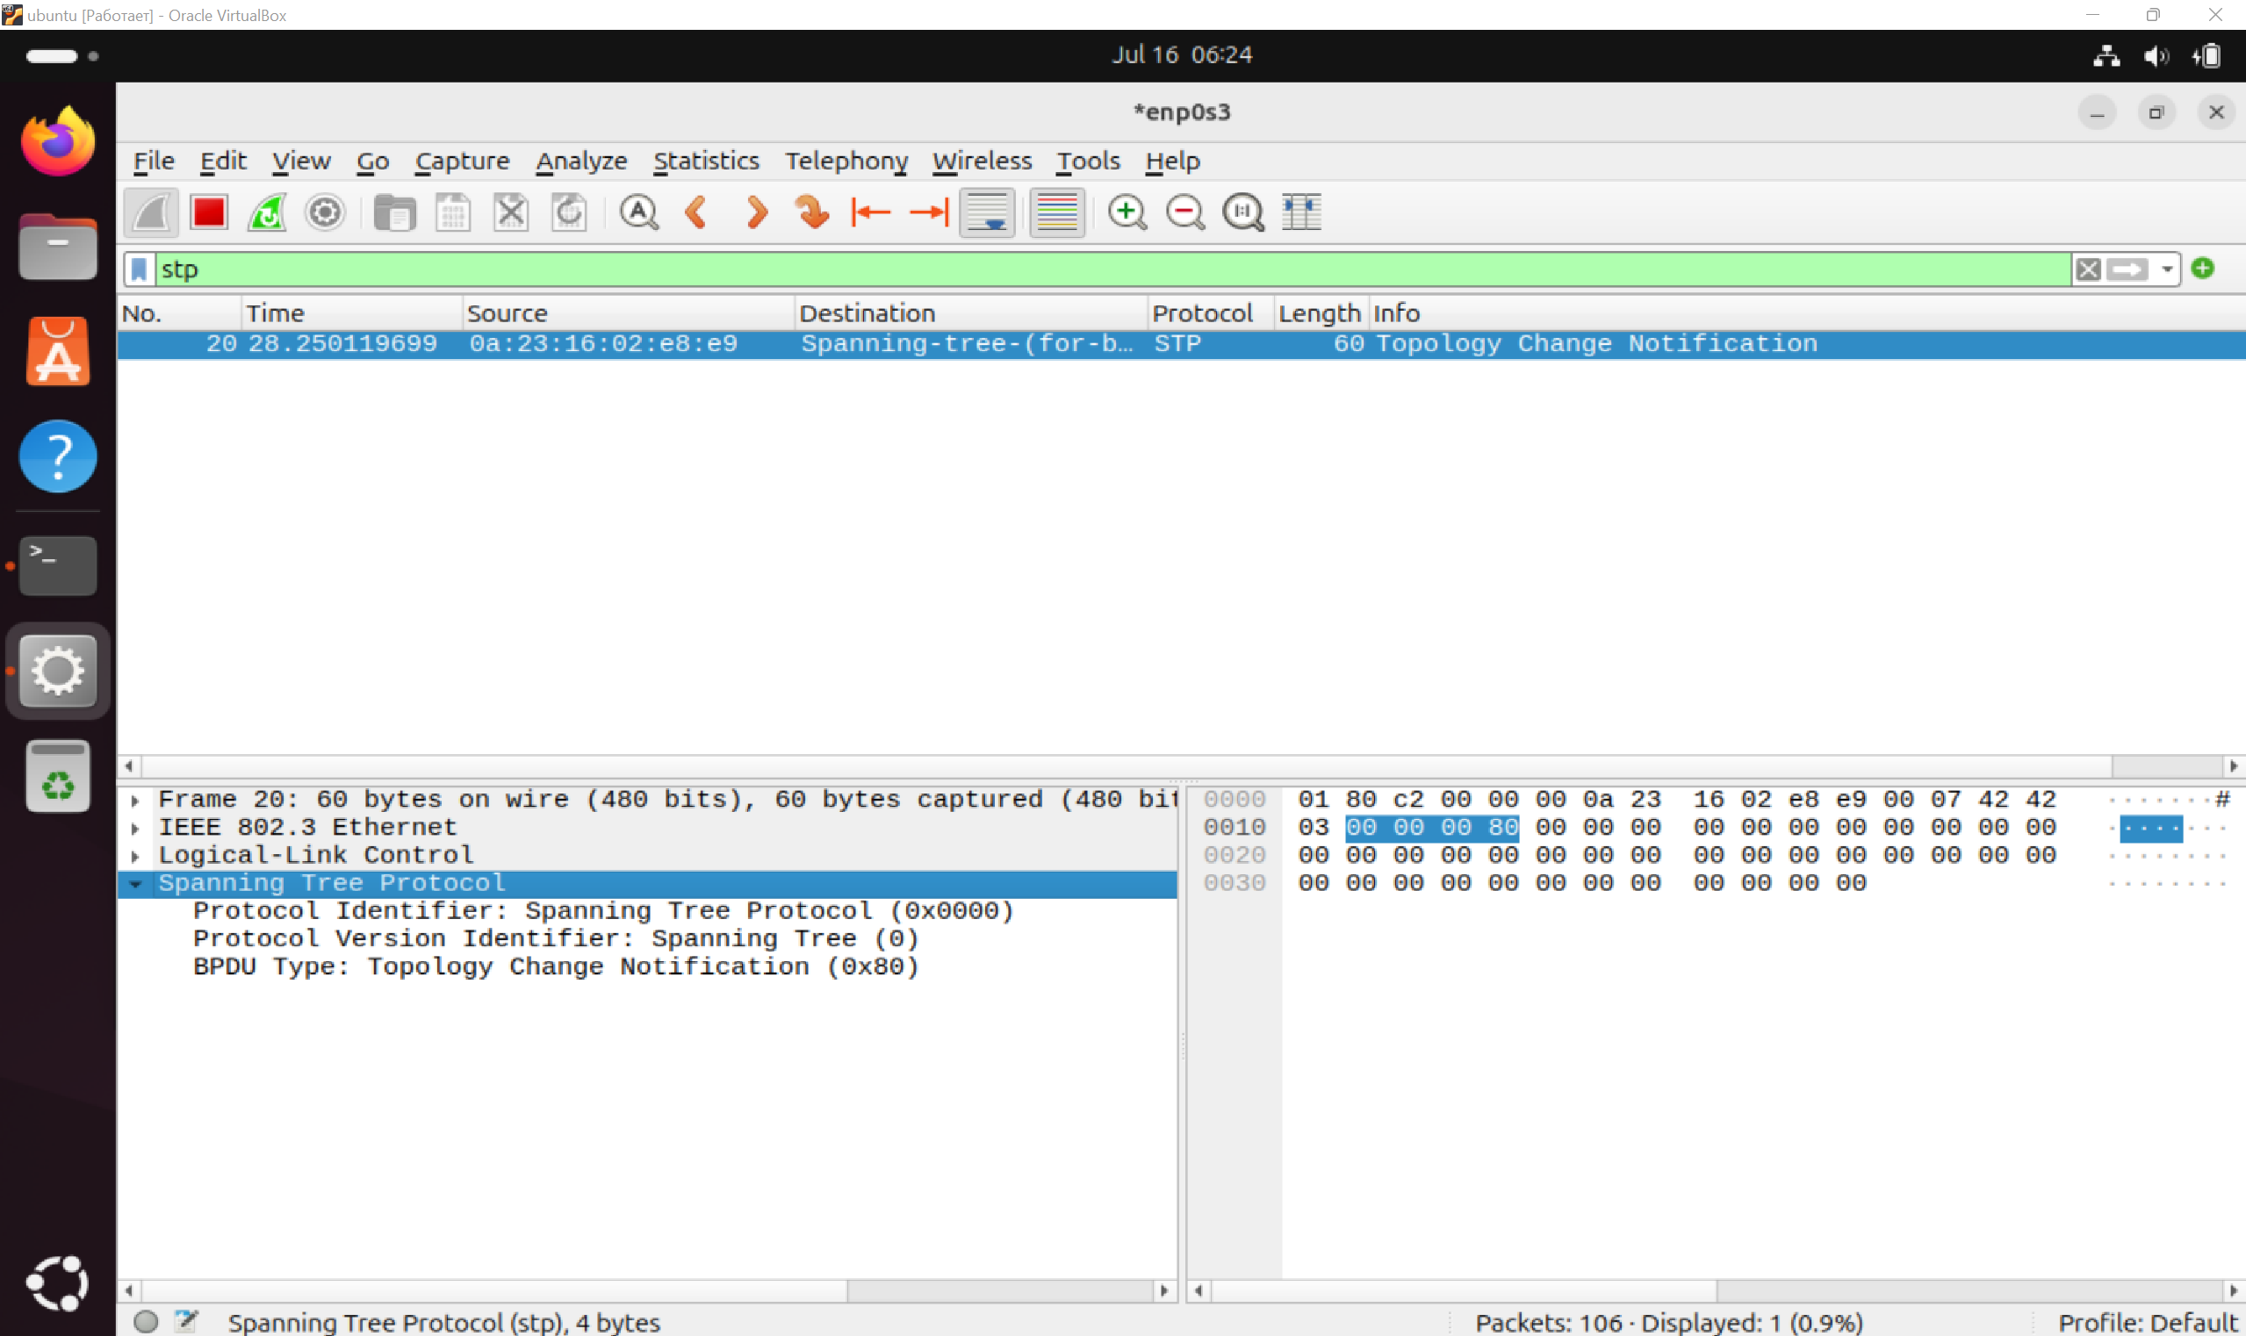

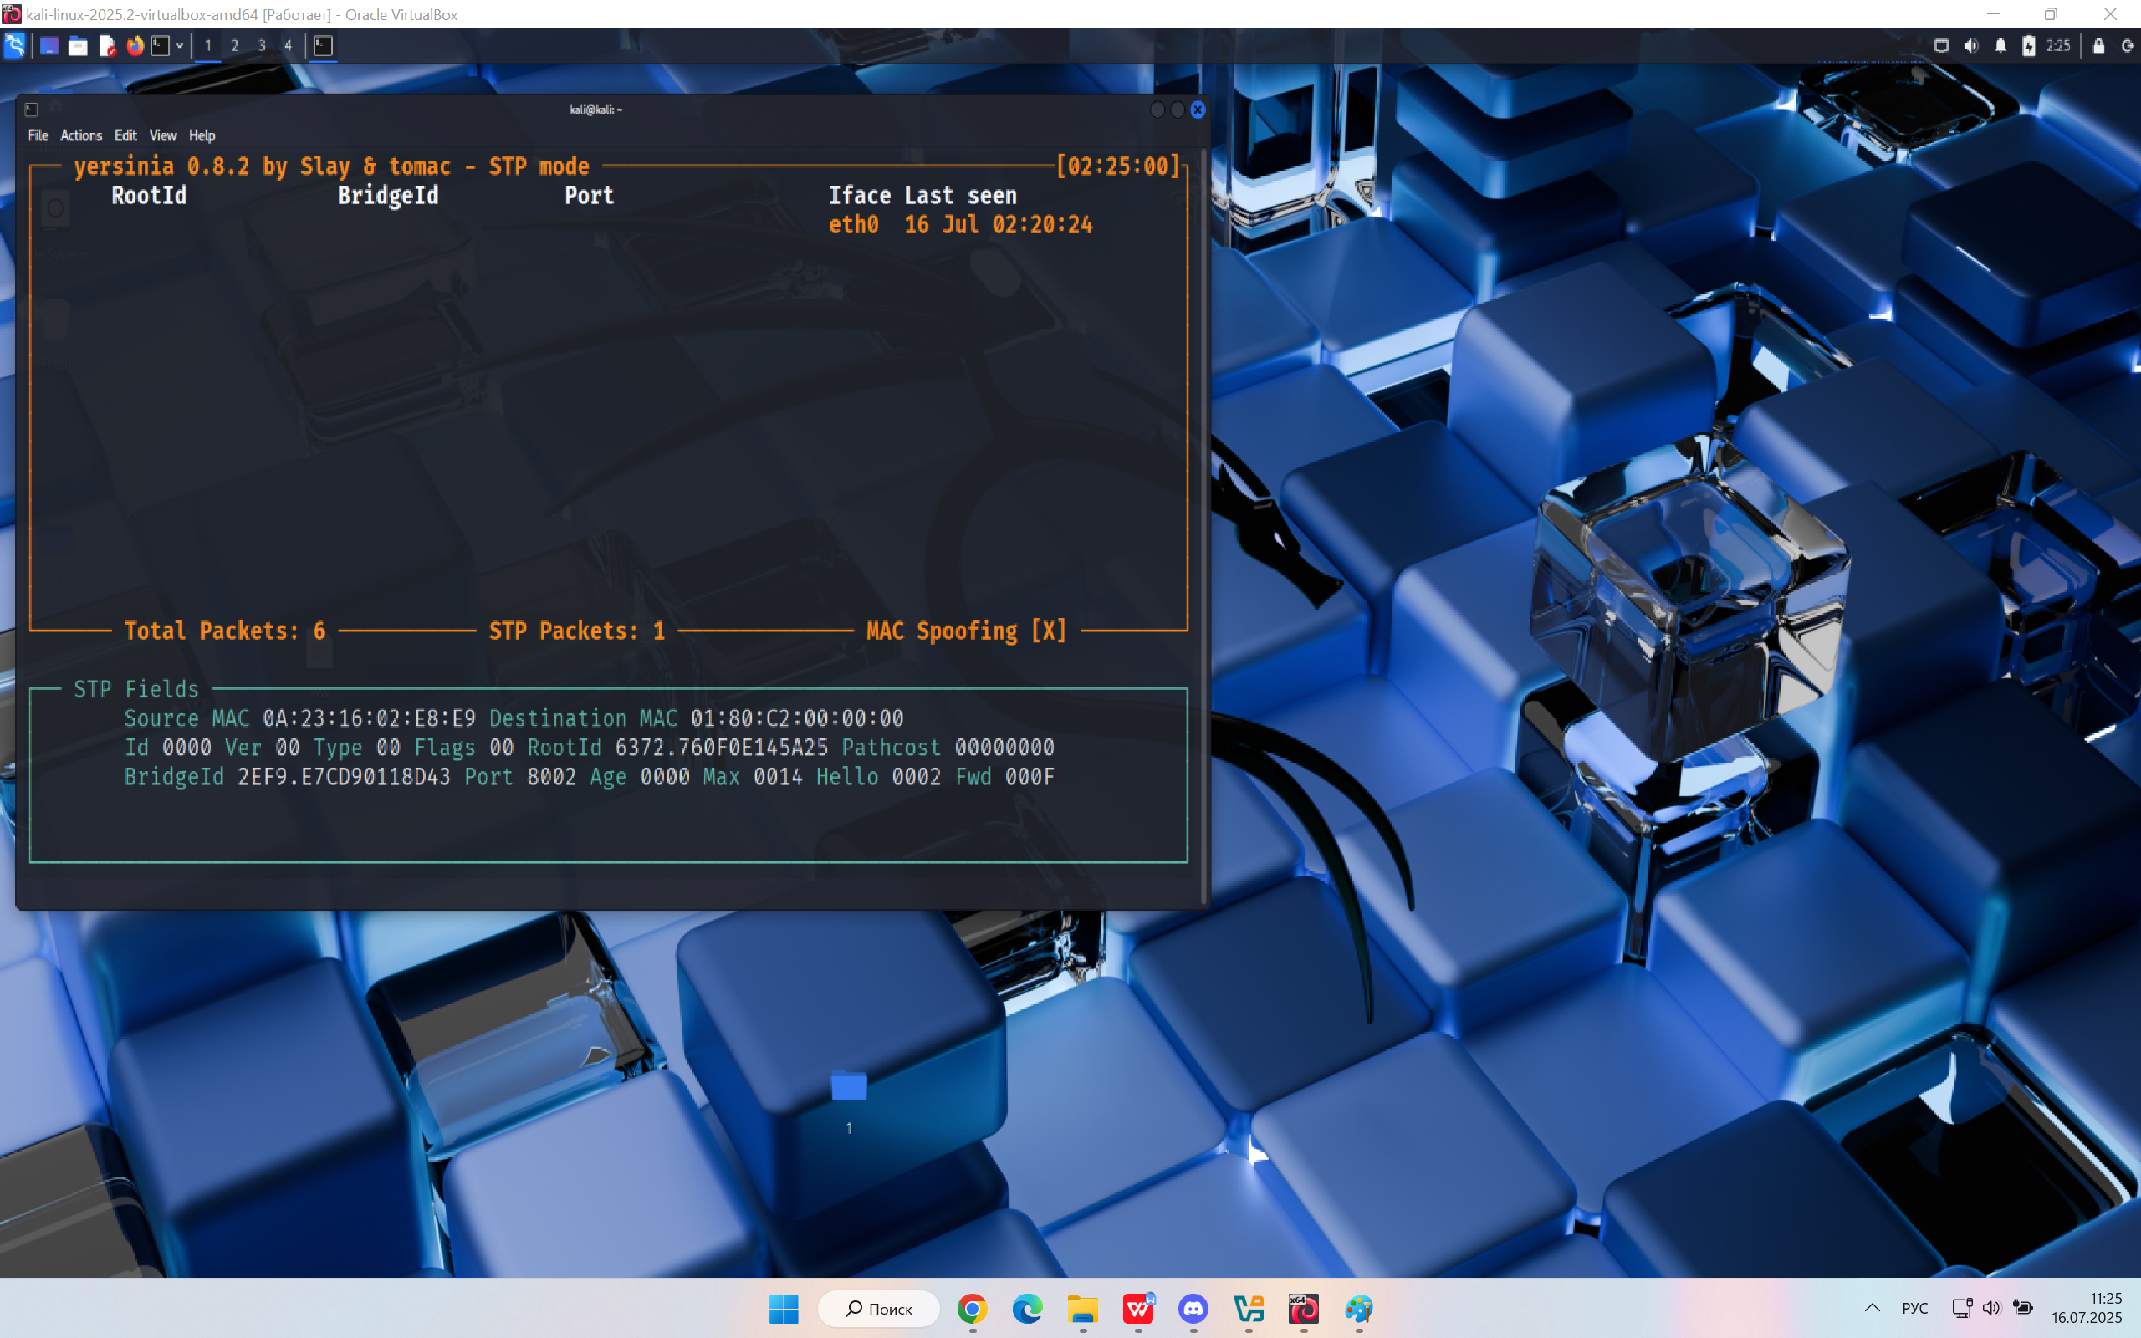

## Attack 2

**Type:** Flood with BPDU configuration packages STP (Spanning Tree Protocol)

**Objective:** Simulating the behavior of the new Root Bridge to capture the main role in STP and force switches to recalculate the topology. The goal is to destabilize the network, cause interruptions and delays.

**Expected Outcome:**

The appearance of a large number of BPDU packets from different MAC addresses

STP will try to recalculate the topology

The network may experience time delays and instability.

Potential disruption of routing between network segments

**Process:**

Kali Linux is running in a virtual machine with the Yersinia utility installed.

An attack has been initiated through the interface of the Yersinia utility

Wireshark is running in a neighboring Ubuntu VM to intercept and analyze traffic.

The display filter is set: stp.

Incoming BPDU configurations (type 0x00) with different MAC addresses were observed in real time.

**Test Result:**

Wireshark recorded many Configuration BPDU packets sent from various MAC addresses (example: d4:37:17:31:a8:ff).

Each BPDU contained:

The Topology Change flag (0x01),

Root Bridge name with high priority (40960/3909),

Full STP parameters: Hello Time – 2s, Max Age – 20s, Forward Delay – 15s.

The traffic went to the multicast address STP: 01:80:C2:00:00:00.

Attempts by many devices to "declare" themselves as a Root Bridge have been detected, which indicates effective flood generation.

**Conclusion:** The attack was successful:

We managed to simulate fake STP configuration packages.

The STP protocol was forced to respond to multiple attempts to change the Root Bridge.

Such an attack can destabilize a Layer 2 network, causing:

recalculating the topology,

time gaps in data transmission,

delays in routing.

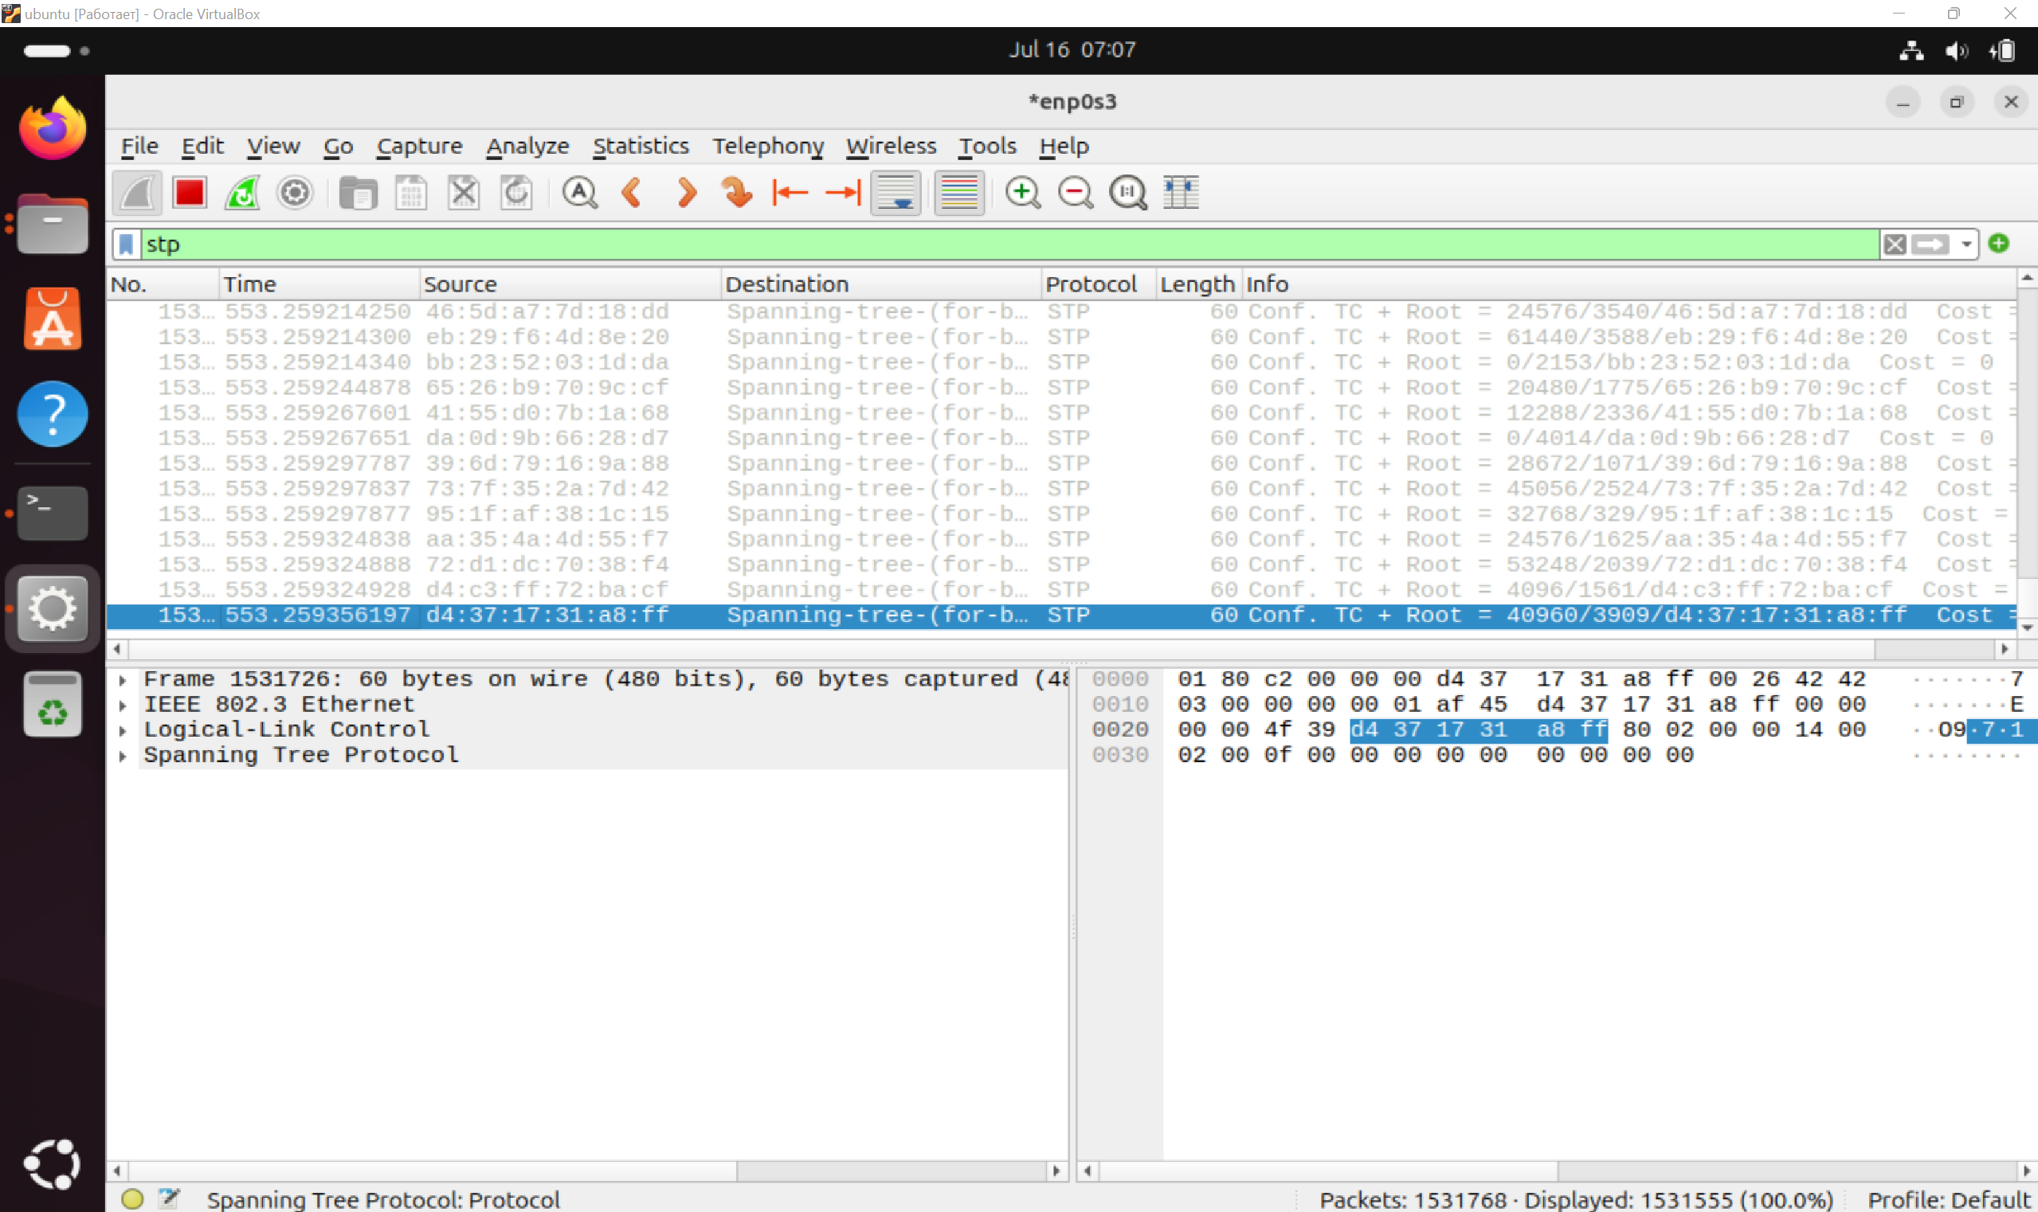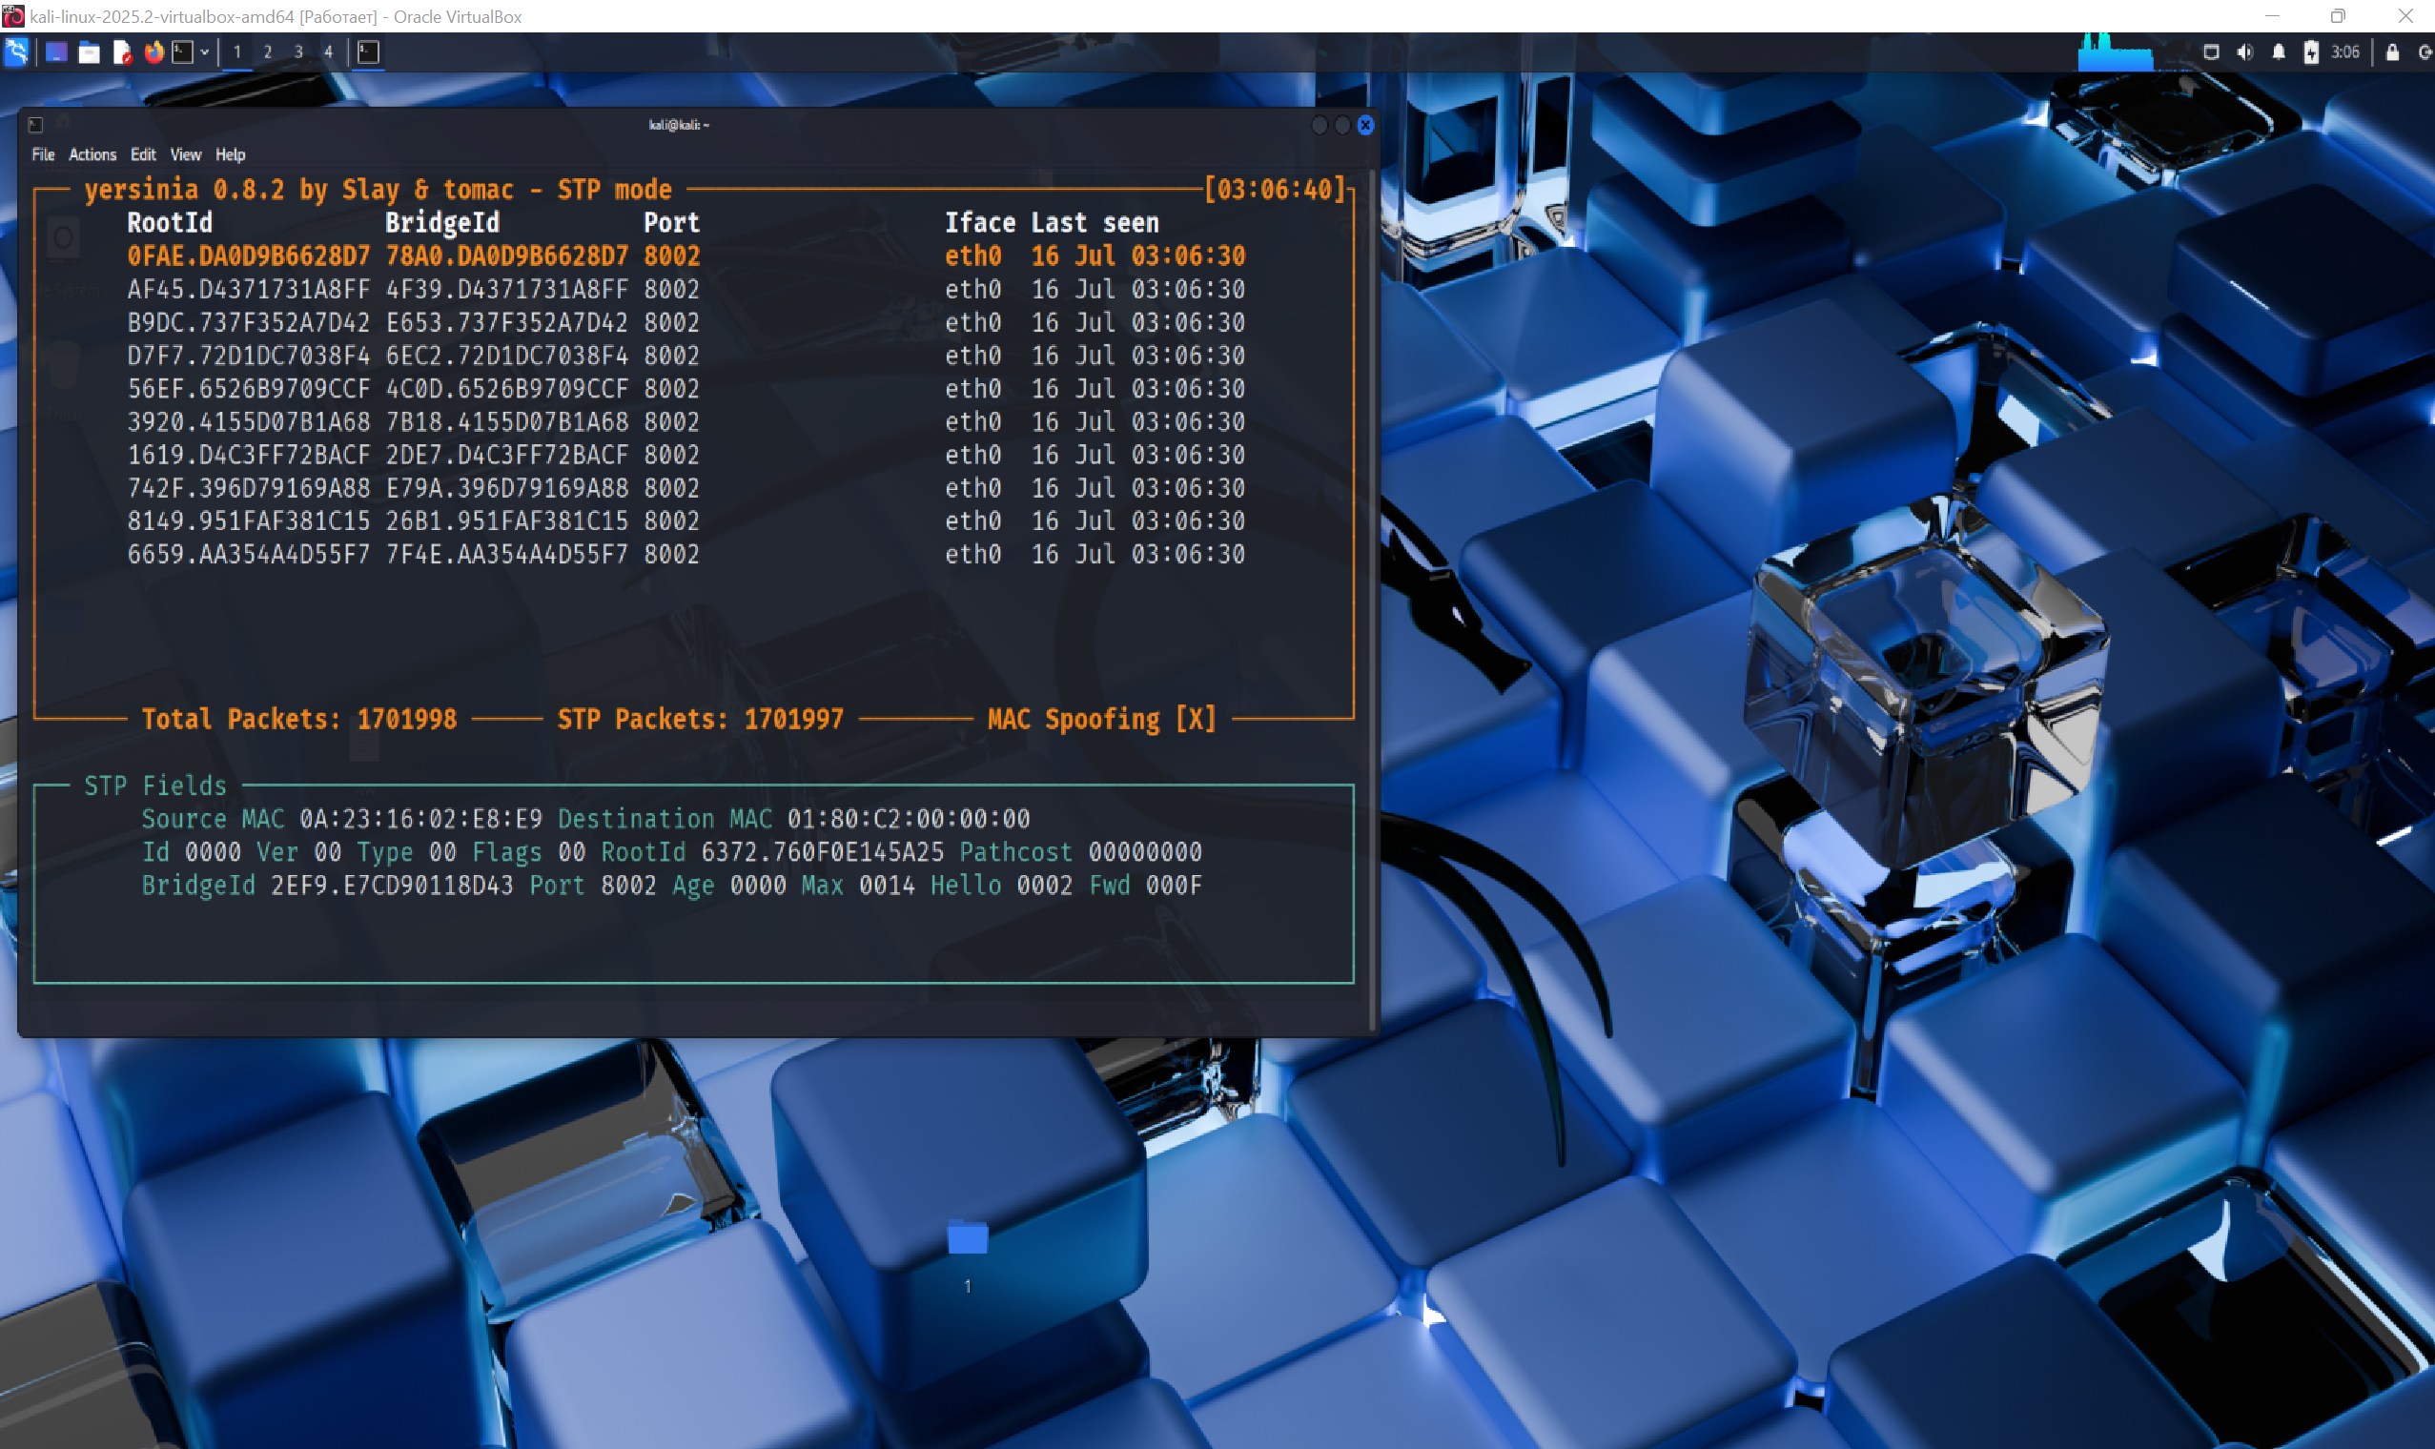

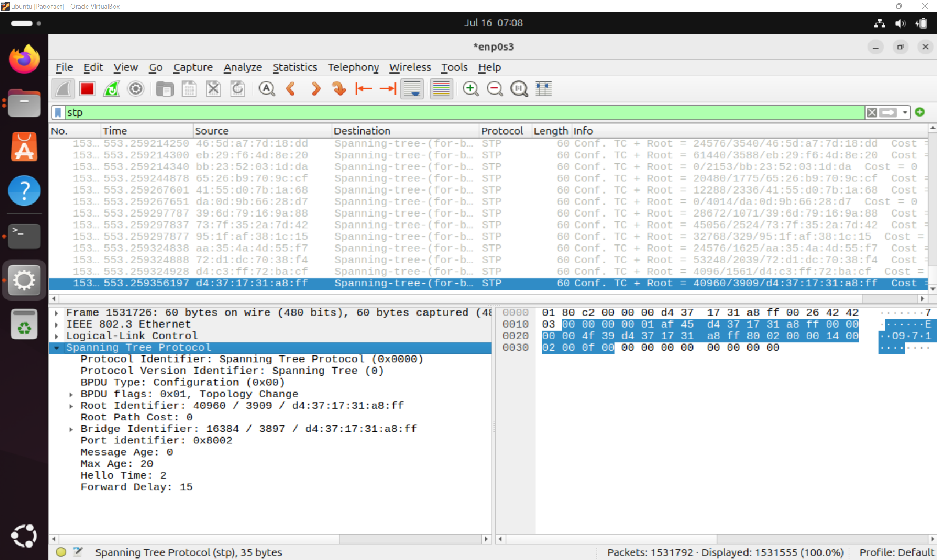

## Attack 3

**Type:** A layer 2 attack is a simulation of network topology changes by sending TCN BPDU packets.

**Objective:** Check how the network reacts to a simulated topology change event by sending TCN BPDUs from the attacking device. The goal is to cause instability in the STP and force other switches to update their MAC address tables.

**Expected Outcome:**

TCN BPDU packets (type 0x80) will appear on the network.

Switches will start updating MAC address tables more frequently due to the Topology Change flags.

There may be a temporary decrease in performance or delays in traffic transmission.

**Process:**

**An attack has been launched in the Kali terminal**

**Monitoring:**

**TCN BPDU packets are fixed in Wireshark**

**Test Result:**

TCN packets were successfully fixed by Wireshark on Ubuntu.

Example of a captured packet: Protocol Identifier: 0x0000; Version: 0; BPDU Type: 0x80

The sending took place regularly, from different MAC addresses.

**Conclusion:** The attack was successfully simulated. The network reacted to false TCN BPDUs as if they were real topology changes: Switches could start updating MAC tables more often. This can be used by attackers to: data theft (MITM attacks), network destabilization, level 2 security bypass. 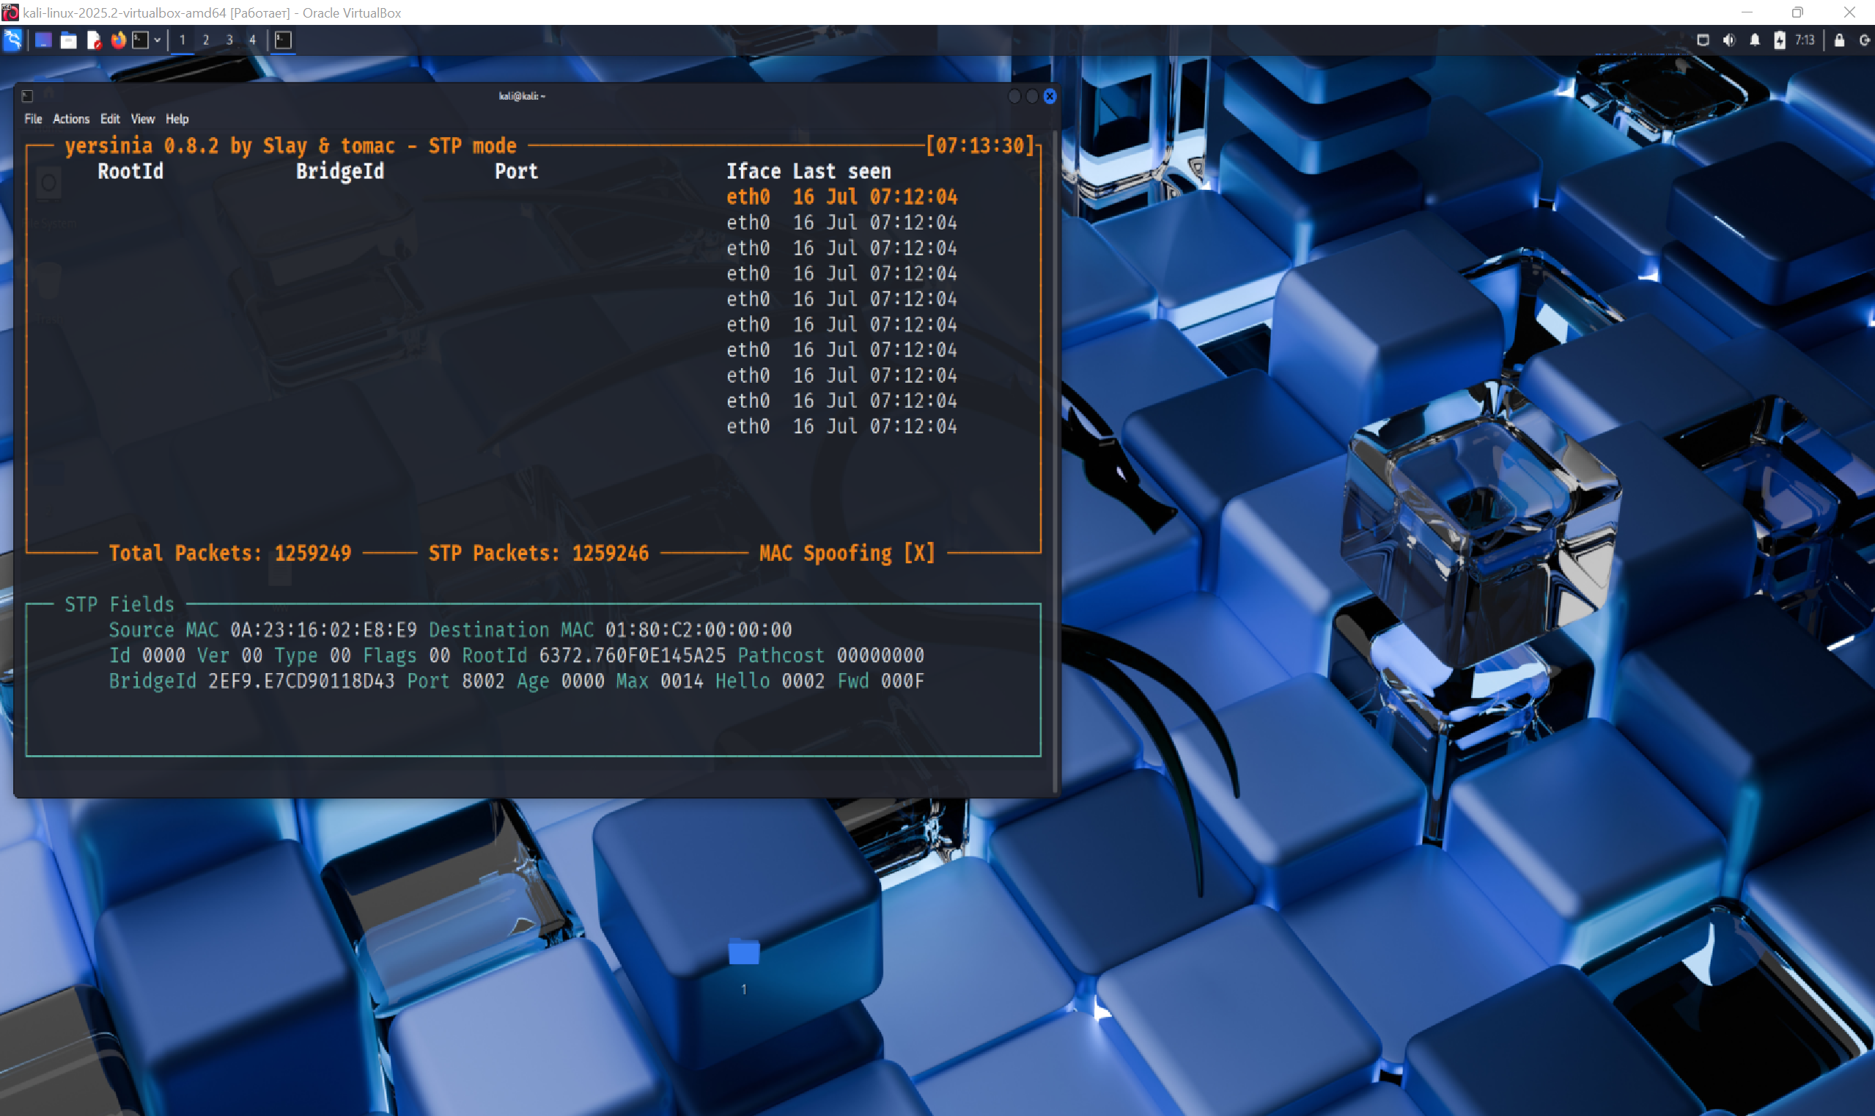

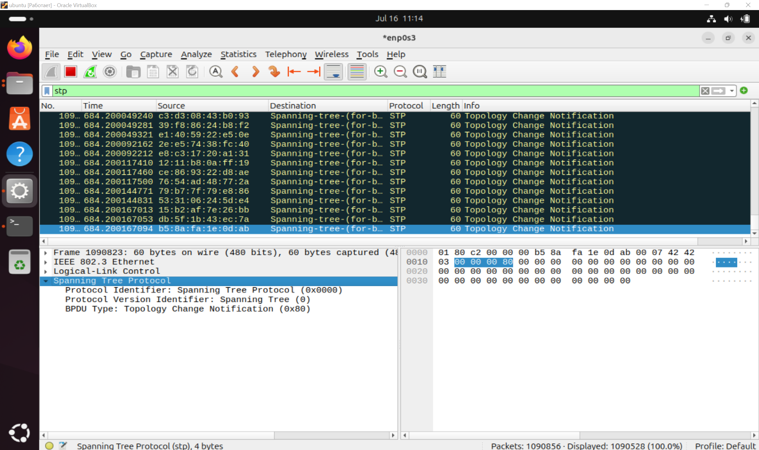

## Attack 4

**Type:** STP Attack – Spoofed Root Claim

(Substitution of the Root Bridge role using fake configuration BPDUs)

**Objective:** Send BPDU packets with minimum priority and a fake MAC address to force the network to accept the attacking machine (Kali Linux) as the main switch, the Root Bridge.

**Expected Outcome:** The rest of the network participants (in particular, Ubuntu) must accept the attacker as the new Root Switch, which will lead to a recalculation of the STP topology. This can cause network instability, loops, or change channel priorities.

**Process:**

Kali Linux is running with the Yersinia tool.

Attack #4 (Claiming Root Role) is selected — activated.

Yersinia transmits BPDU packets with a reduced priority (Priority = 0) and a MAC address posing as the Root Bridge.

Wireshark is running on Ubuntu, the stp filter is active.

Kali Linux uses the Bridge Adapter network mode, the interface works in promisc mode.

Packets do not appear in Wireshark, despite an active attack.

**Test Result:**

The attack remains active in the Yersinia interface, which confirms its launch.

None of the STP packets are captured in Wireshark on the receiving side.

The network remains stable, and no Topology Change or Root ID change has been detected.

**Conclusion:**

The results of the attack demonstrate high protection on the part of the receiving machine (Ubuntu):

STP packets are probably filtered at the kernel or driver level - Ubuntu does not process STP traffic because it does not participate in the protocol as a full—fledged network participant.

Wireshark is configured correctly, however, someone else's L2 traffic with STP flags simply does not get into the system.

Thus, the test showed a successful attempt to send an attack, but an unsuccessful implementation due to the refusal of the receiving party to interact with fake BPDUs.

.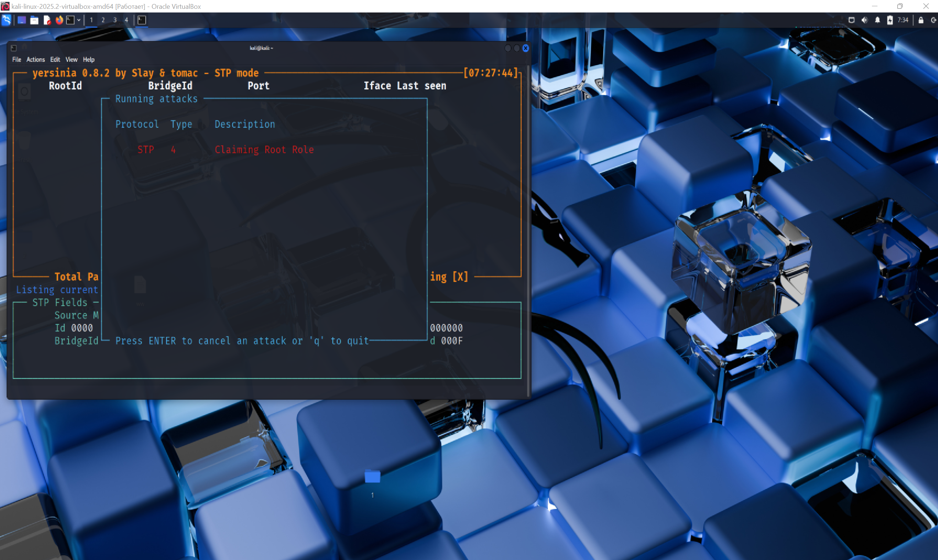

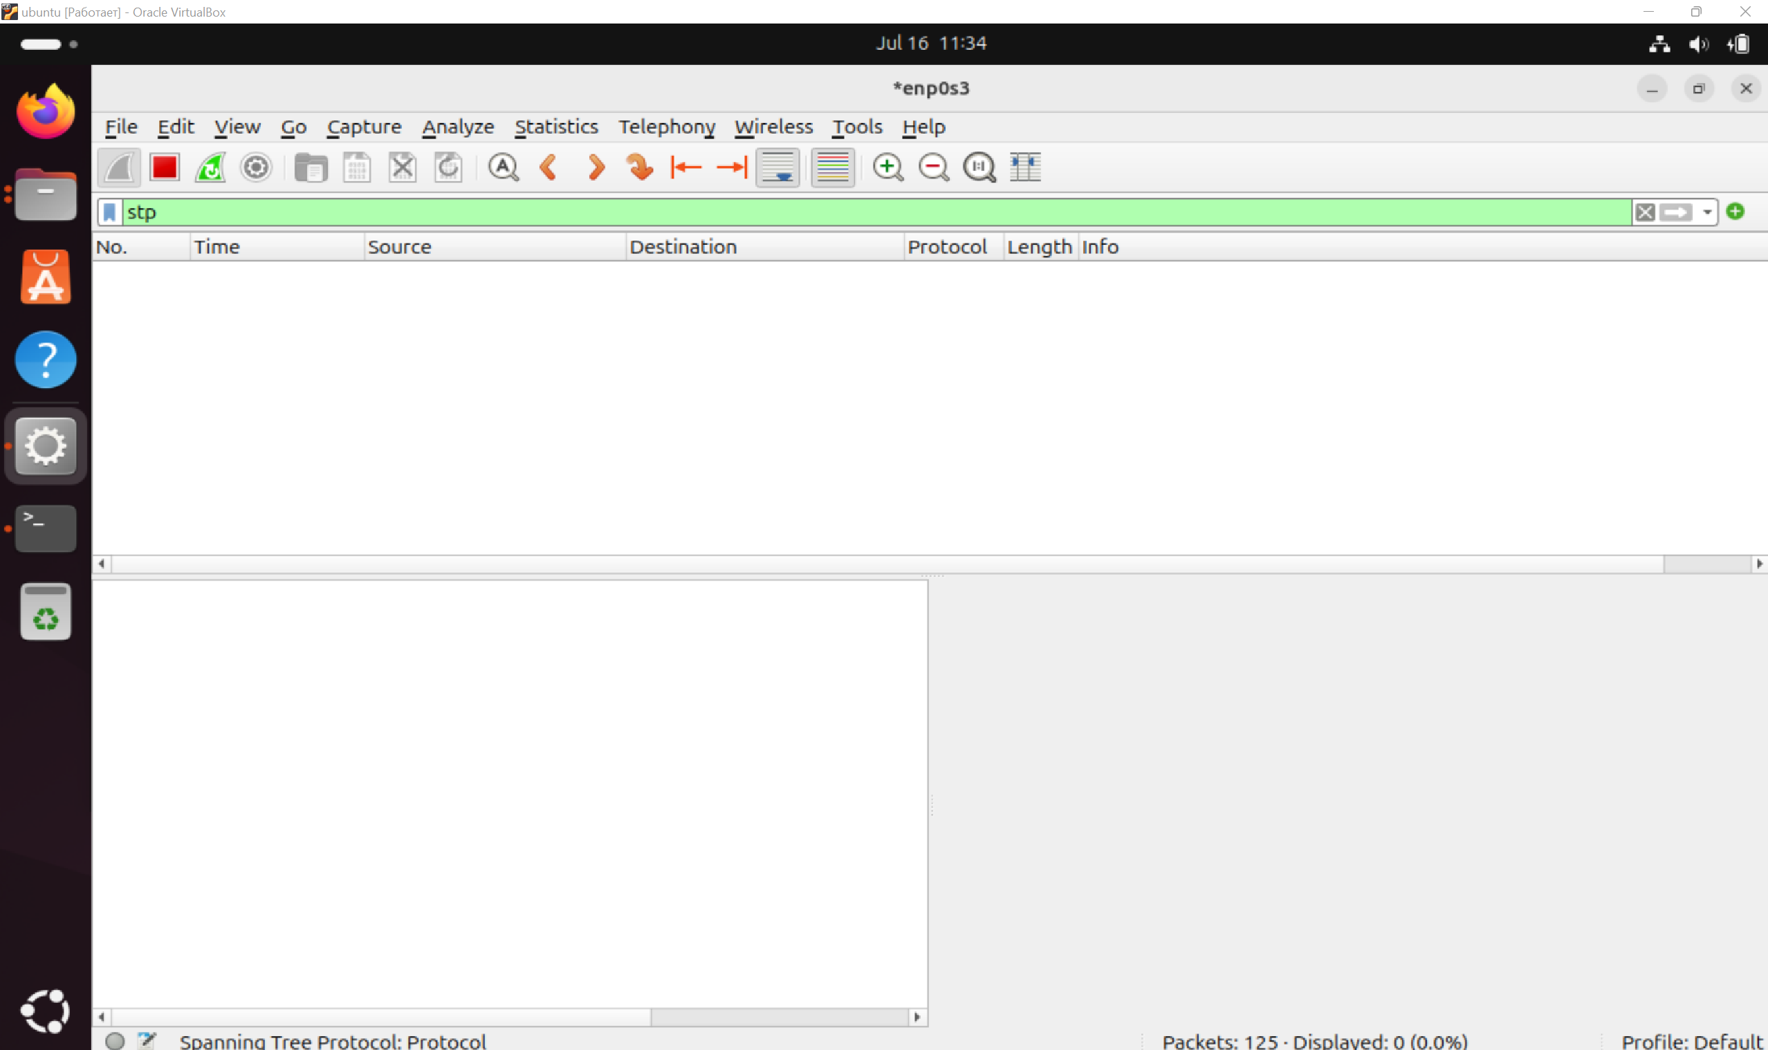

## Attack 5

**Type:** STP Attack – Spoofed Bridge Role Claim

(Faking the role of a regular bridge switch, not Root)

**Objective:** Send BPDU packets on behalf of a switch that claims to be a non-Root role, but is still involved in STP, in order to try to influence the topology calculation logic, for example, to take a higher priority path or cause a partial network rebuild.

**Expected Outcome:** The STP on the recipient's side (Ubuntu) must fix the new "Bridge", send a response, or change the status of the ports. This could have caused a recalculation of the Designated Port / Blocking Port role and a temporary delay in traffic transmission.

**Process:**

Kali Linux runs Yersinia.

Attack No. 5, Claiming Another Role, is activated.

Kali generates and distributes BPDU packages that do not pretend to be Root, but show themselves as a member of STP.

Ubuntu is set to receive, Wireshark works with the stp filter.

VirtualBox is used in Bridge mode, the interface is in promisc mode.

**Test Result:**

Attack No. 5 is hanging in the Yersinia interface as active.

No STP packets related to this attack are recorded in Wireshark.

There are no changes in the STP topology, and there are no responses from Ubuntu.

The status of ports in the system does not change.

**Conclusion:**

Similar to attack #4, the result indicates a successful launch, but unsuccessful delivery or response. Possible reasons:

STP frames could have been discarded by the host kernel or network stack as irrelevant.

Since Kali claims to be an ordinary STP participant, without aggressive Root claims, the network response is minimal.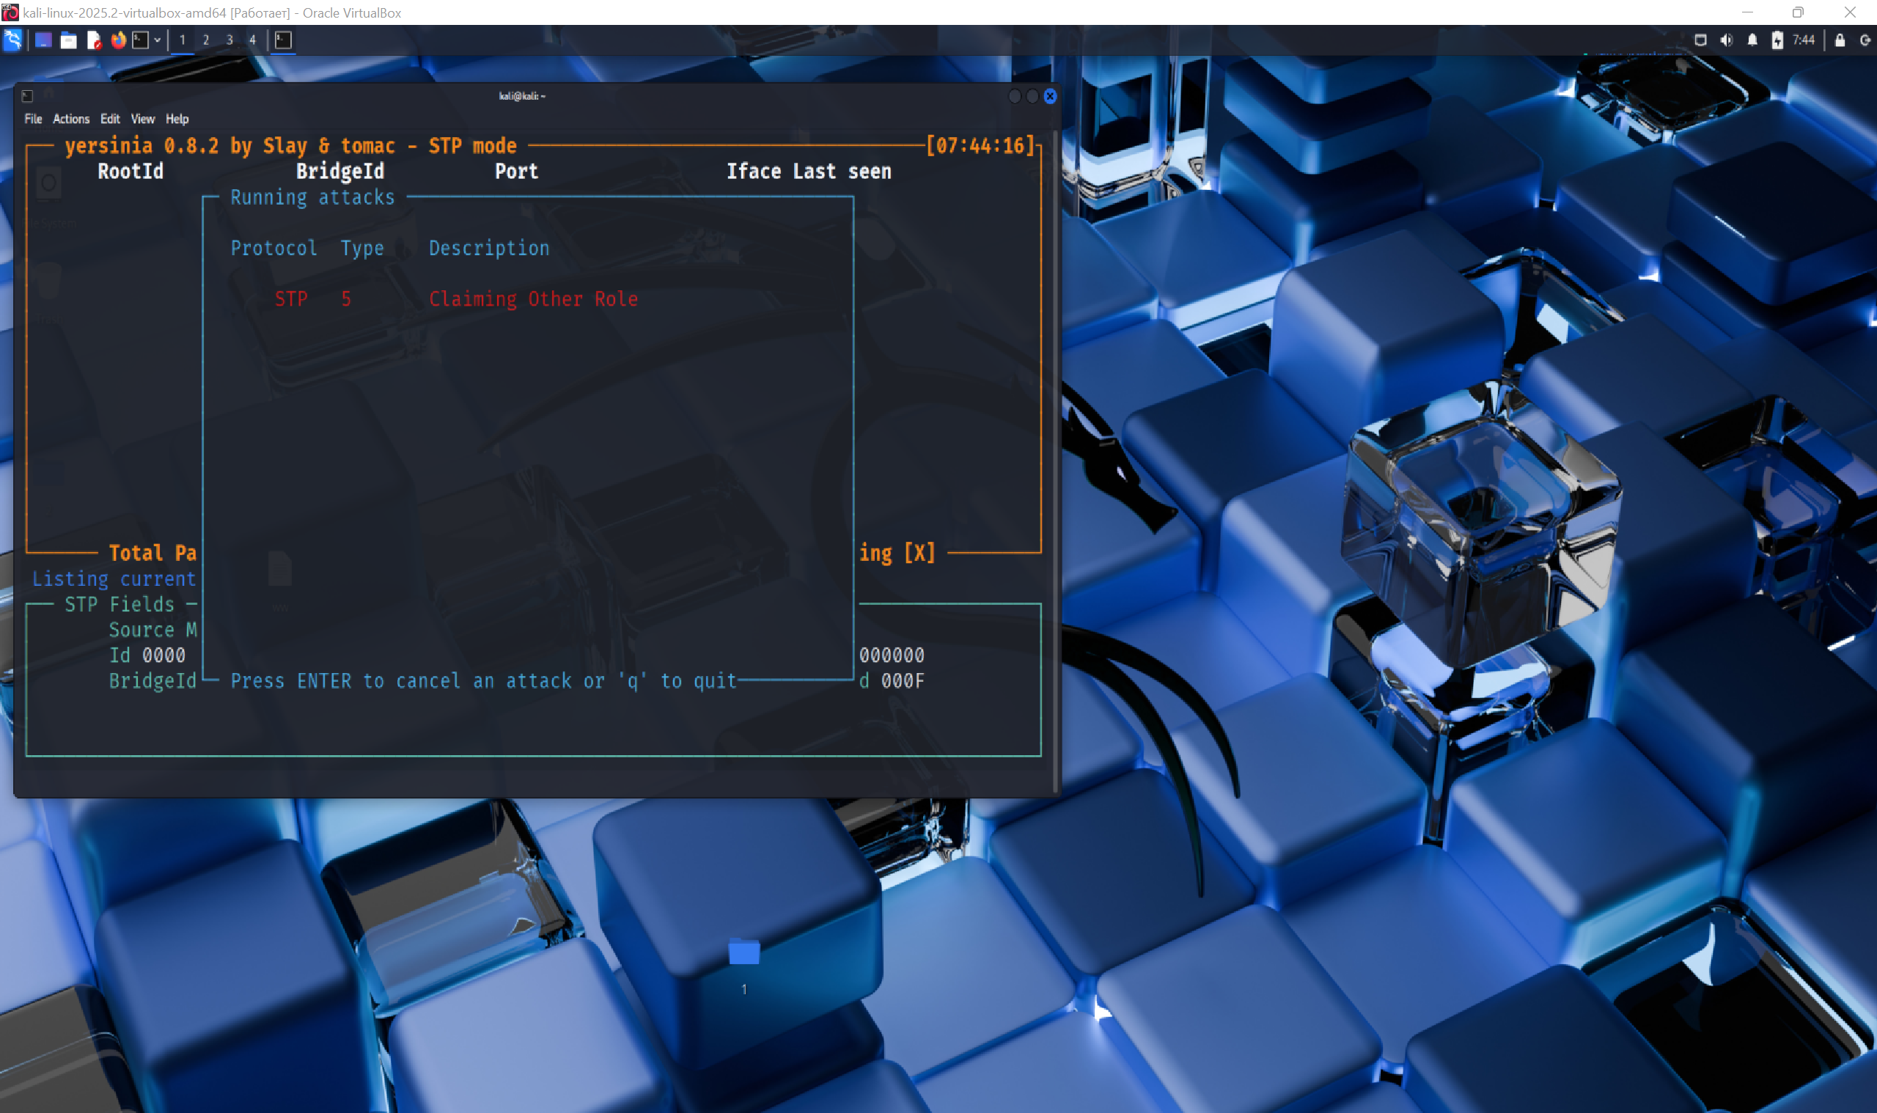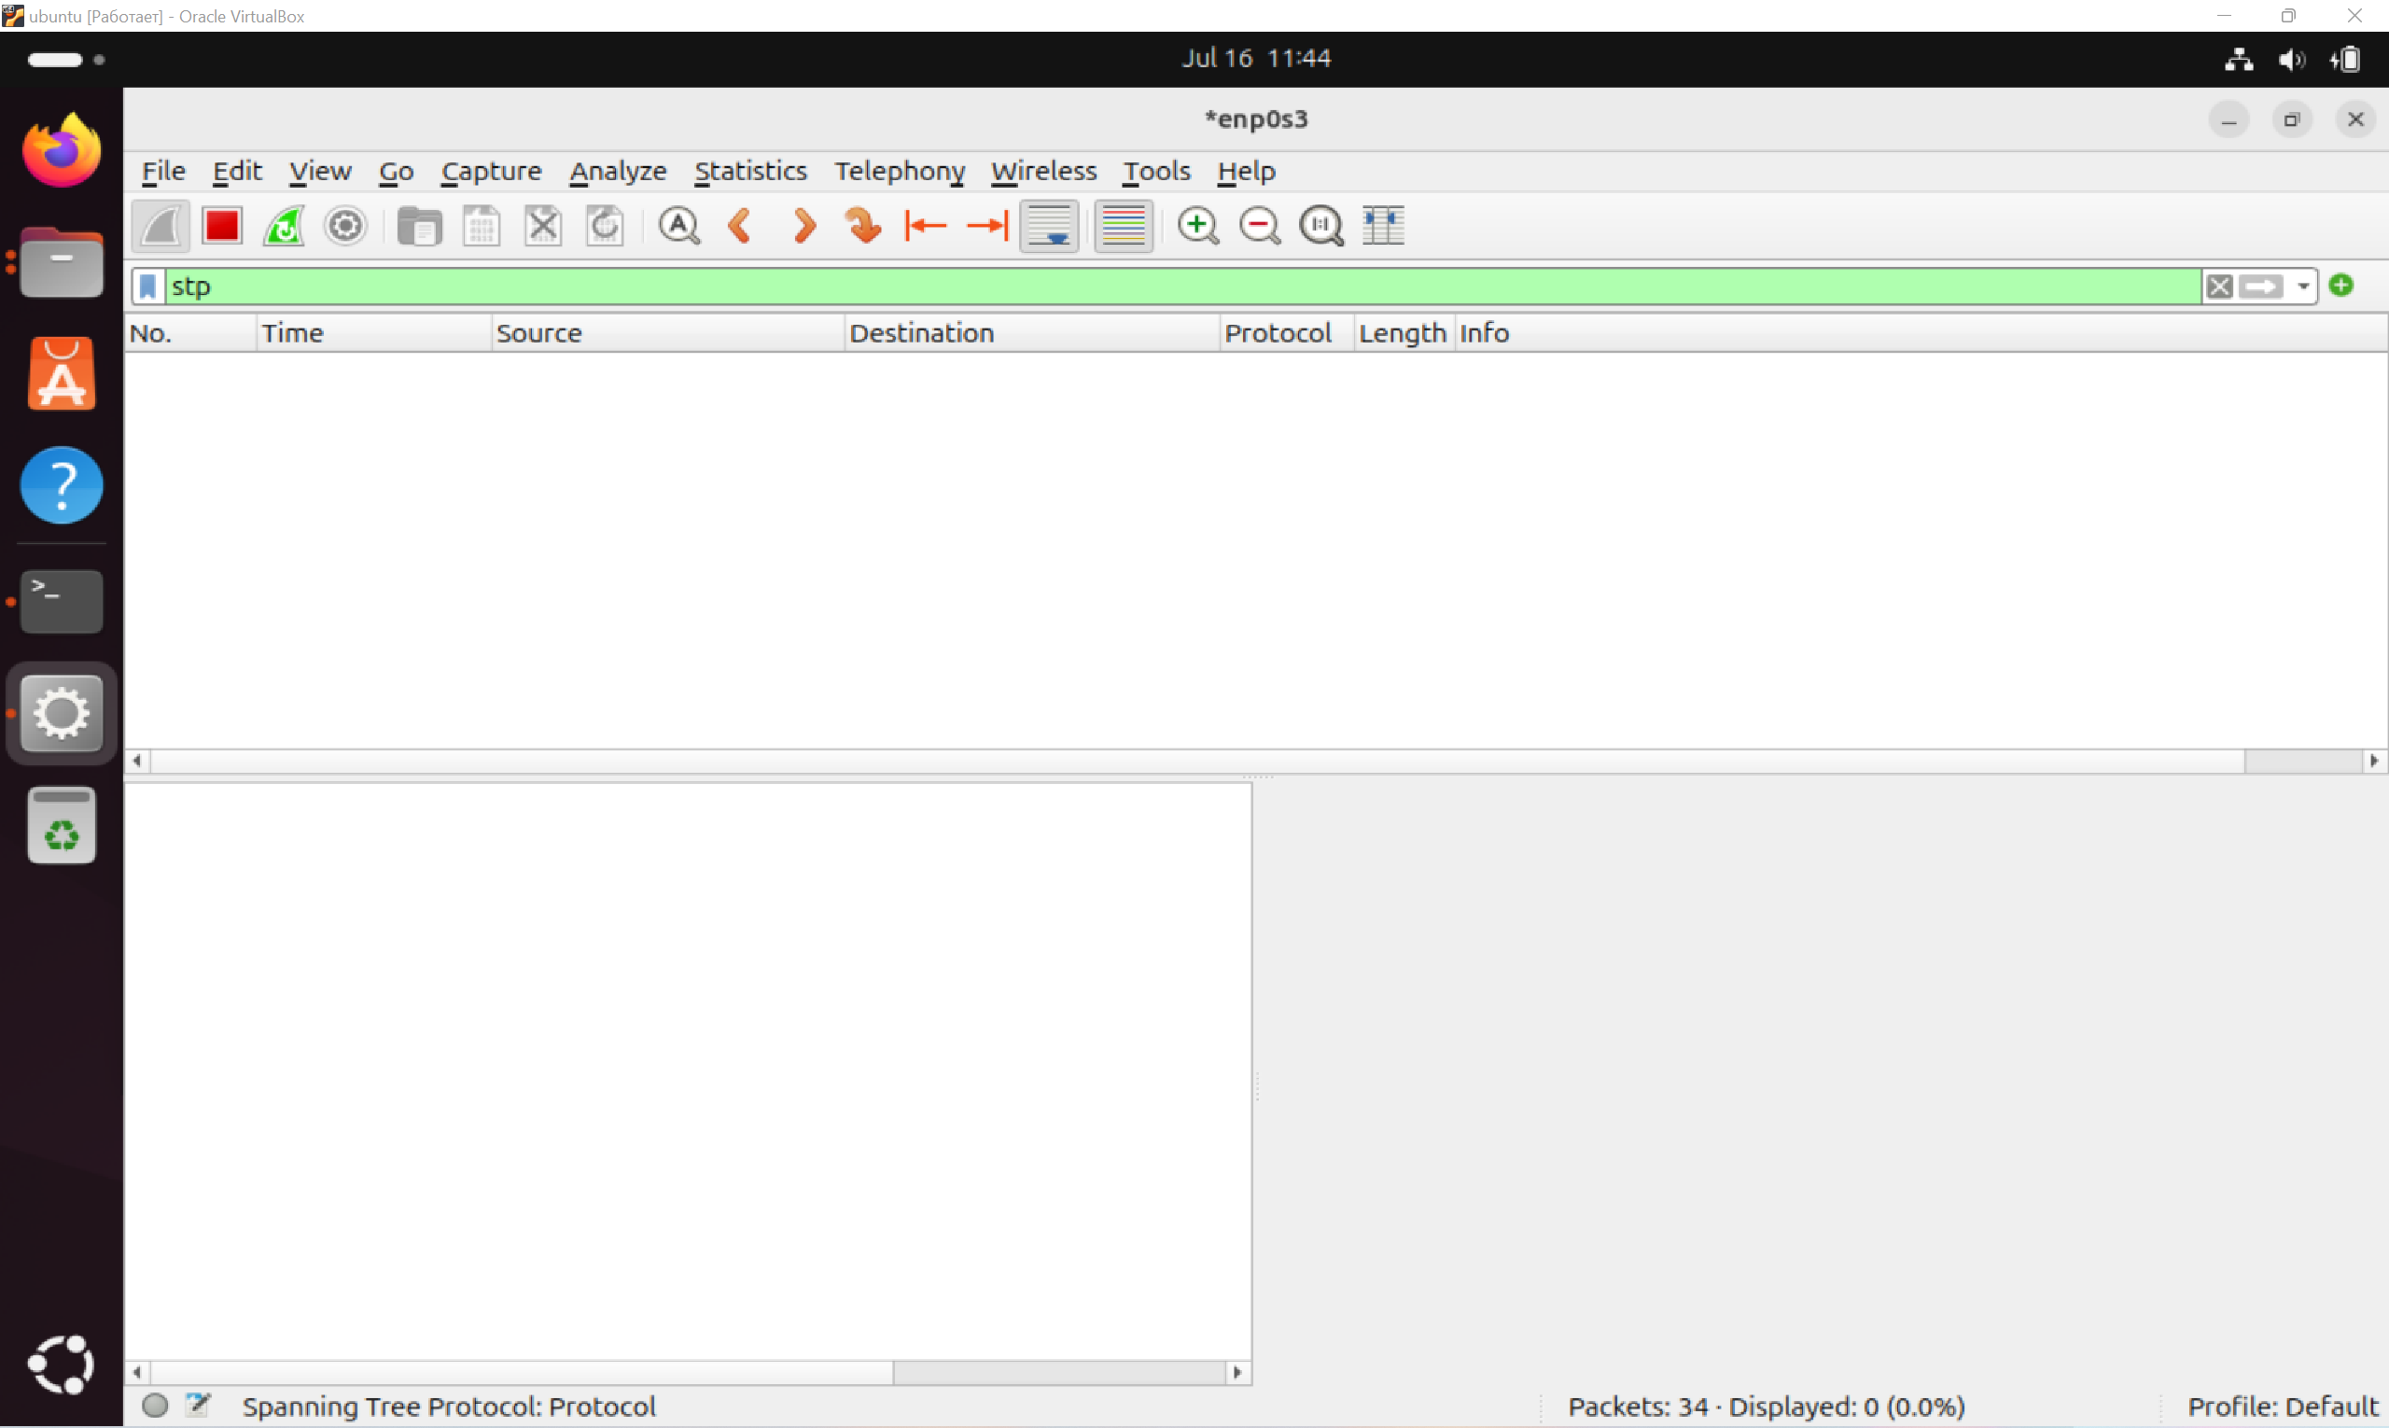

## Attack 6

**Type:**  STP Attack – **Root Role Claim with MITM (Man-in-the-Middle)**

**Objective:** Declare yourself as a new Root switch and change the network topology so that all L2 traffic passes through the attacker (Kali Linux). This opens up the possibility of intercepting, altering, or delaying traffic at the second level.

**Expected Outcome:**

Kali becomes the Root Bridge in the eyes of STP.

The entire topology is being rebuilt, and traffic is routed through Kali.

Wireshark records changes to the Root ID and BPDU flood.

The possibility of MITM attacks on other protocols (for example, ARP, DHCP, DNS).

**Process:**

Kali Linux запускает Yersinia.

Выбрана атака №6 – Получение роли Root в MITM.

Ubuntu is set to receive, Wireshark works with the stp filter.

**Test Result:**

Kali Linux sent BPDU packets (visually confirmed in Yersinia), claiming the Root role.

The Root Priority has been lowered (possibly to 0), and the MAC address has been changed.

No packets were received in Wireshark on the Ubuntu side.

The network was not rebuilt.

The traffic has not changed the route — the MITM has not been reached.

**Conclusion:**

Despite the correct implementation of the attack from the technical side (choosing roles, priorities and launching in Yersinia), there was no reaction from the network. Possible reasons: Ubuntu is protected from STP forgery or simply does not process STP (as an end device).

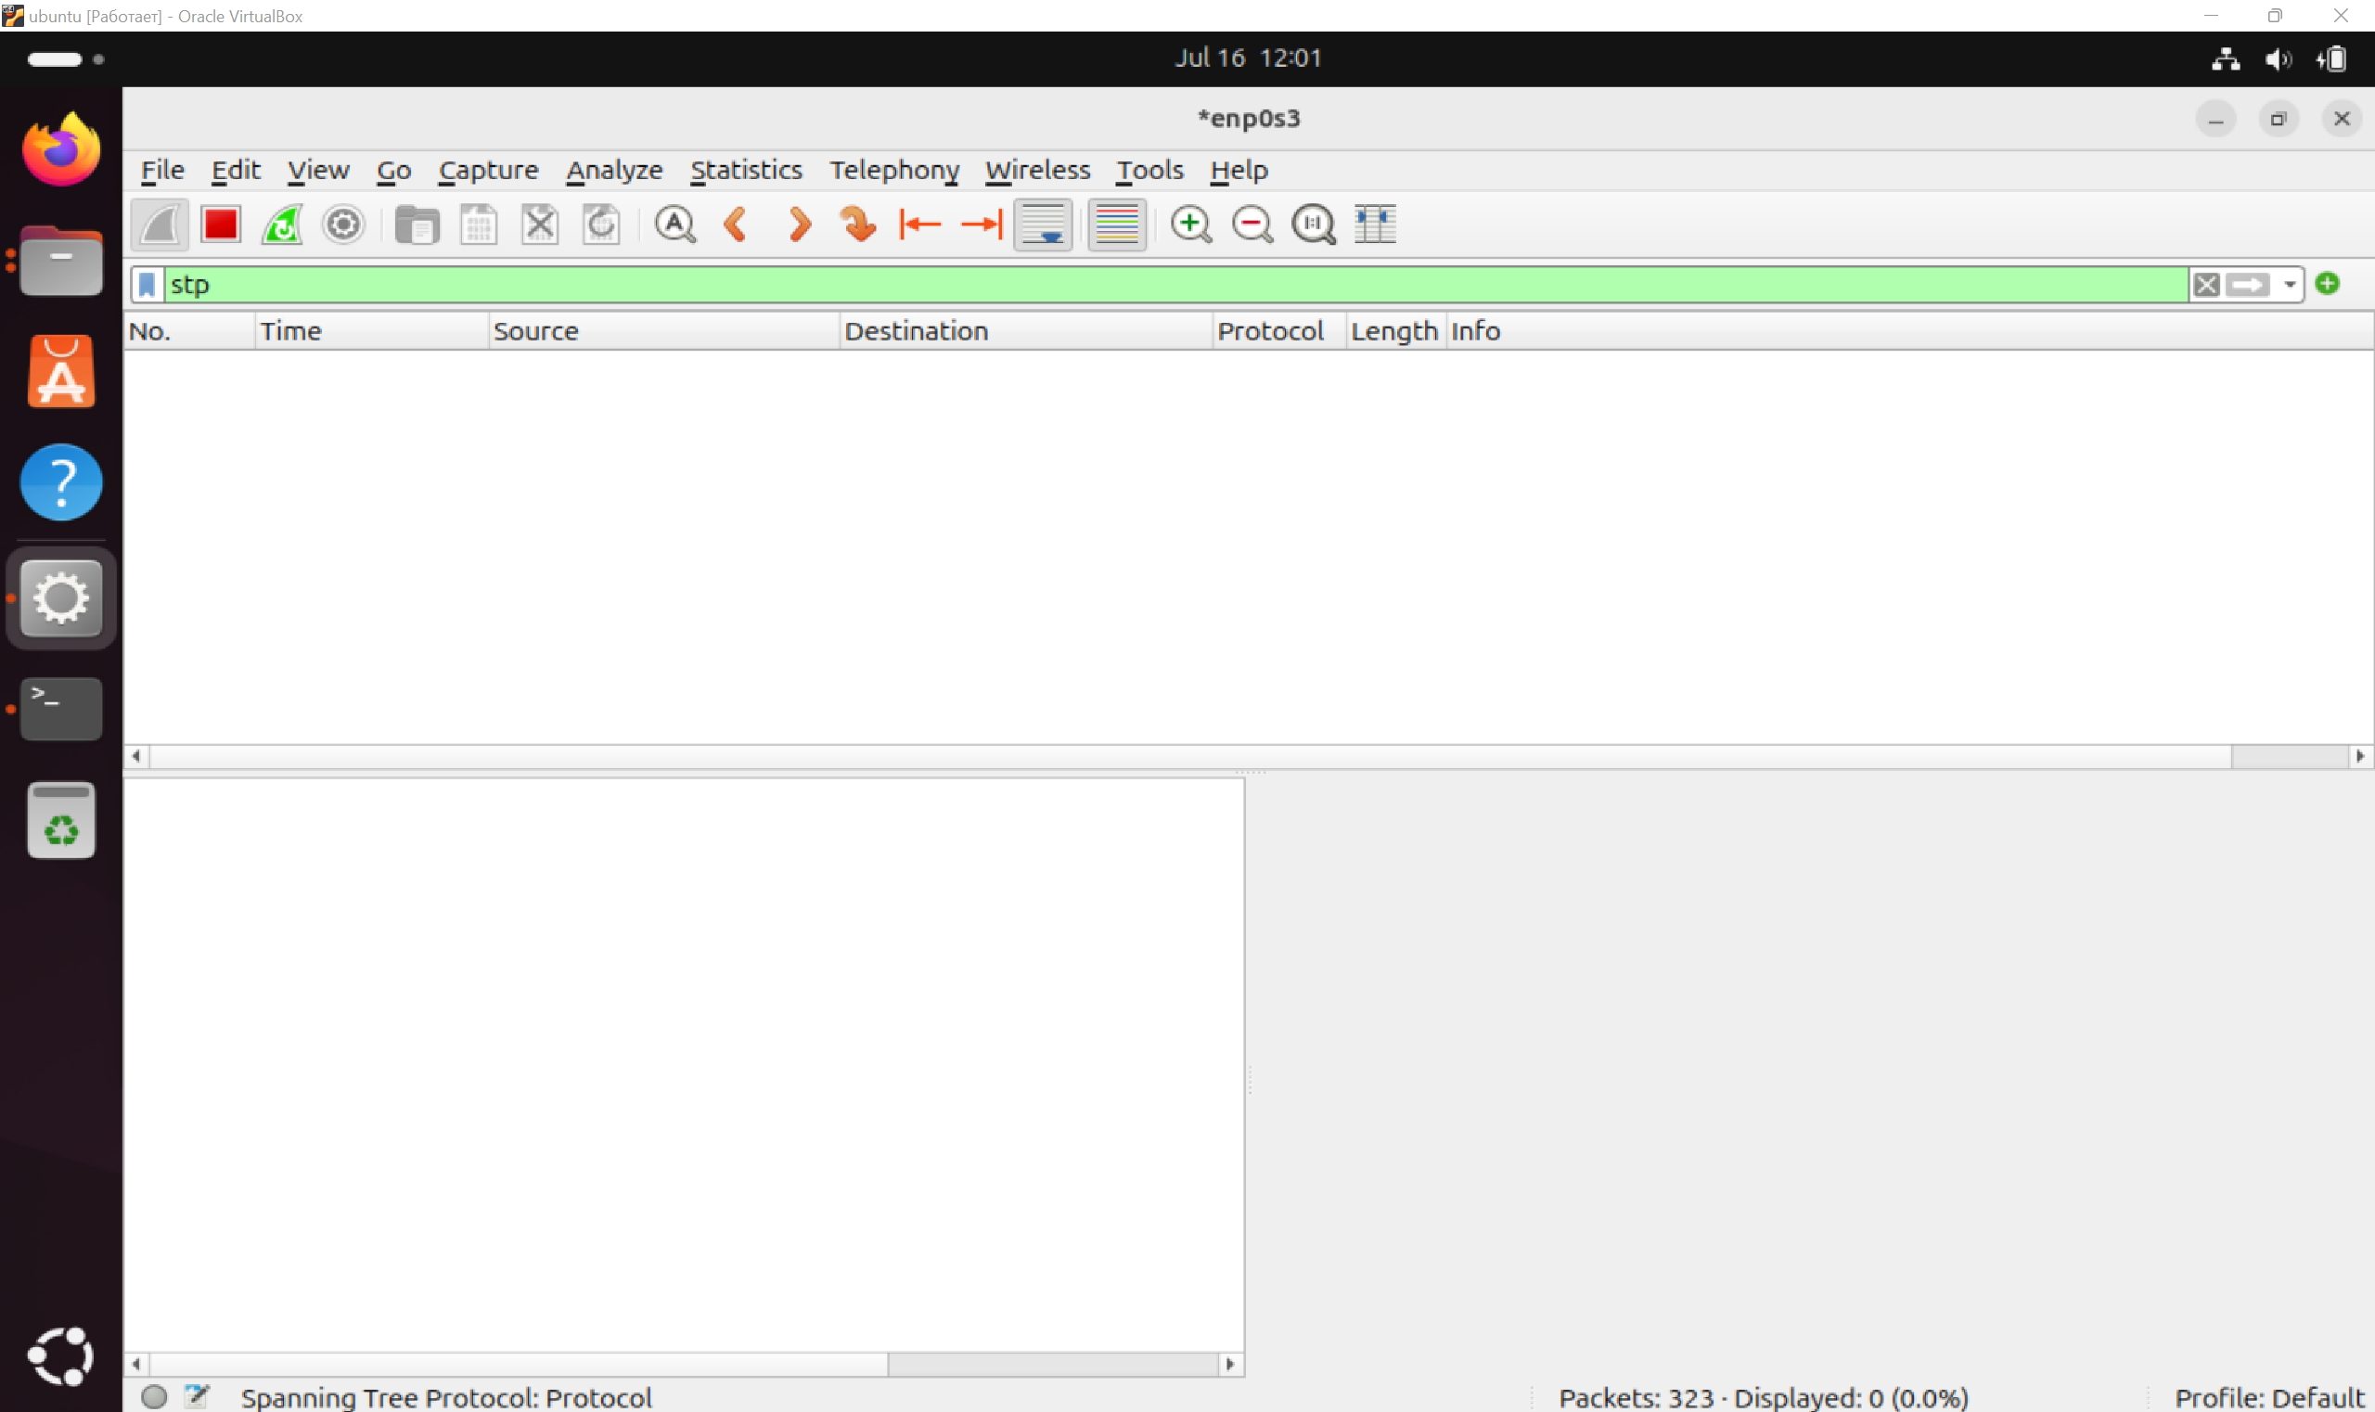

# 4. Packet Analysis

The analysis was performed in Wireshark with an stp filter. The following fields were studied: BPDU Type, Root ID, Bridge ID, Port ID.

Attacks 0, 1, 2, 3:

The packets were successfully intercepted. The BPDU structure is valid, and changes to the Root ID and BPDU Type correspond to the target of the attack.

Attacks 4, 5,6:

Packages are not fixed — probably Ubuntu's security mechanisms (for example, BPDU filtering or blocking non-standard roles).

# 5. Conclusions

Successful attacks:

0 (Flood), 1 (TCN), 2 (BPDU), 3 (TCN Flood) — attacks have been sent and are visible in Wireshark, which confirms ownership of STP attacks and traffic analysis.

Unsuccessful attacks:

4, 5, 6 — packets did not reach the receiver.

Safety conclusions

An Ubuntu-based network probably uses BPDU filtering.

Protection can include Root Guard, BPDU Guard, or MAC filtering.

For the Red Team: successful BPDU generation confirms the possibility of implementation with weak protection.

For SOC: Root ID and TCN frequency monitoring is a key indicator of an attack on STP.